AI in a nutshell

AI or Artificial Intelligence, a new technology that is promised to take over the world and simplify our lives. But, what is AI and how does it work? What’s the difference with Machine Learning and Deep Learning? And what kind of AI systems are there? Well, I’m here to rescue and to help you see the wood through the trees.

Definition and goal.
The easiest way to understand AI, is to place it in the context of humans. Humans can see, listen, hear, process, read, understand, speak and all kinds of stuff. All these typical human trademarks can be placed in a context of AI. Originally Artificial Intelligence is a broad branch of computer science, the study of processes that interact with data and that can be represented as data in the form of programs.
The main goal of AI is to make systems that can function intelligently and independently.

Types of AI’s.
There are 2 big ways of how AI works: Symbolic Learning and Machine Learning.
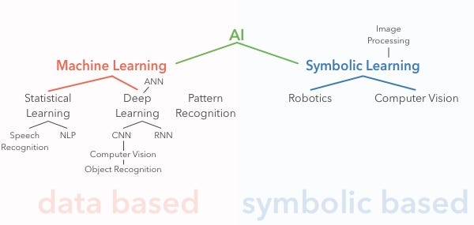
A schematic overview of AI.

Symbolic Learning
Image Processing
Recognizing, understanding and creating images of a specific scene falls under the field of image processing. It isn’t a specific field of AI but is required for a working Computer Vision technique.
Computer Vision
Humans can see and look with their eyes and process these images. Computer Vision falls under the symbolic way of processing images but is also a part of Convolution Neural Network and Deep Learning. Object Recognition is completed through Computer Vision.
Robotics
Moving around in an environment that a human understands is the field of robotics.

Machine Learning
Machine learning is the scientific study of algorithms and models used by computer systems to perform a specific task without relying on instructions but on patterns and inference instead. It builds a model based on sample or training data to make predictions or decisions. More data and dimensions of data make it easier for machines to be better at pattern recognition.
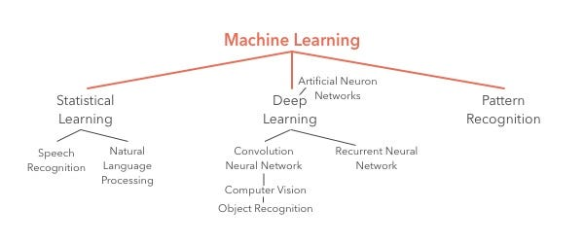
A schematic overview of Machine Learning.
Statistical Learning
The field of statistical learning covers everything that can be statistical proven and understand.
Speech Recognition
This type of AI can be compared to the communication system between people. Most of us can speak, listen and understand each other through language, what makes us quite unique.
Natural Language Processing
This contains writing, reading and understanding written language. Often Natural Language Processing will be shortened by NLP.
Deep Learning
Deep learning is based on Artificial Neuron Networks. It uses multiple layers of ANN to transform data in higher-level features. This explains the word “deep” in deep learning. The chain of causal connections between the input and output of data in deep learning is called credit assignment path (CAP).
There are multiple types of techniques for deep learning and machine learning to replicate what the biological brain does.
Artificial Neuron Networks
Artificial Neuron Networks, or ANN, covers the working of cognitive capabilities in machines. Artificial Neuron Networks is a vague replication of the human brain that contains the same function. An ANN model is based on a collection of connections or nodes called “artificial neurons”. Each connection transmits a signal from one neuron to another. A signal is a real number. Each connection is called an “edges”. The main goal of ANN is to have a similar working function as the human brain would.
The main differences between ANN’s and biological neurons are:
- ANNS are mostly static and symbolic
- Biological Brain Neurons are dynamic and analog
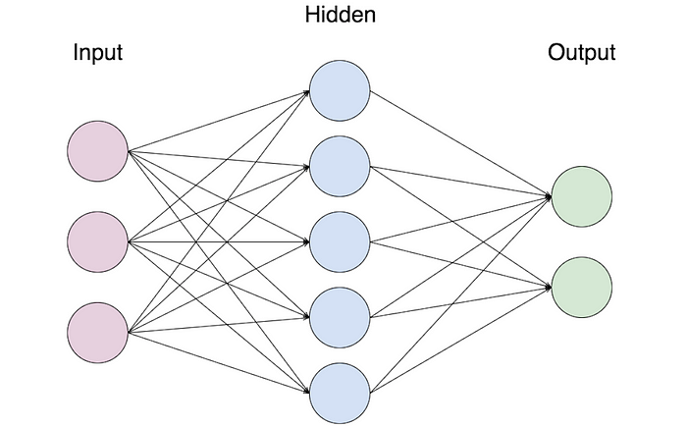
The working of Artificial Neural Networks
Convolution Neural Network
A Convolution Neural Network or CNN is used to recognize objects in a scene so as mentioned before, Computer Vision and Object Recognition are part of this technique. For example, scanning images following a specific scheme.
Recurrent Neural Network
RNN’S can use it’s internal state (= memory) to process sequences of inputs. Just like humans can use their (limited) memory. Connections in an RNN form a directed graph next to a temporal sequence. This allows it to show temporal dynamic behavior.
Pattern Recognition
Recognizing patterns like grouping or assembling similar objects. Recognition starts with data, humans can only acquire this data by learning or experience.

Ways to use Machine Learning.
Machine Learning can be used to achieve to things: classification or prediction/regression.
Classification is used when the desired output should be a grouping of the input. For example, if you want to use data to group customers.
Prediction or Regression is used in case if you want to research a statistical relationship between a dependent variable (the outcome variable) and one or more independent variables (the features). For example, if you want to know if a customer is to defect to a competitor.

Learning Algorithms.
AI, Machine Learning and Deep Learning all depend on perfect functioning learning algorithms. There are multiple types of learning algorithms. I will describe the 3 basic learning methods:
1. Supervised Learning
If you train an algorithm with data that already contains the answer it’s called supervised learning. Each training example is a pair that consists of an input object and the desired output value. It analysis the data and produces an inferred function. For example, when you train a machine to recognize and see the difference between a bottle and a key, you will need to first train the machine with data of the bottle and key.
2. Unsupervised Learning
If you train an algorithm with data where you want to let the machine figure out the answer or pattern. It helps find unknown patterns in data sets without pre-existing labels.
3. Reinforcement Learning
When you give the machine a goal and try to reach it through trial and error, you will be learning it the reinforcement algorithm. The difference with supervised learning is that it doesn’t require labelled input/output pairs. The focus lays on finding a balance between the exploration of unknown territory and the exploration of current knowledge. The machine is trained by a system of reward and punishment. It receives rewards by performing correctly and penalties for performing incorrectly. Over time the machine, or agent, will be making decisions for optimizing its functioning for maximizing its rewards and minimizing punishment. Reinforcement Learning is inspired by behaviorist psychology. A big advantage of this method is that it allows learning without a human describing how it should perform the task. An example of Reinforcement Learning are self-driven cars.
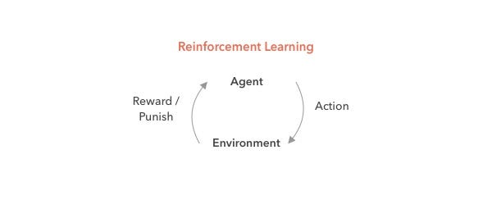
Reinforcement Learning: a schematic overview.
Soooo… We came to the end of this article. But sure not the end of the documentation of AI. I know that I probably left out some important key terms or deeper explanations but I just wanted to give myself and other AI newbies a clear overview. I surely recommend taking your time and reading a lot of articles about AI for further comprehension. Also I want to recommend this short video of Mr. Raj Ramesh that was my main resource for this article.
See you next time!
Nina

Artificial Intelligence

Newbie

Machine Learning

Deep Learning

Techniques

4
1

More from Personal Project
Follow
For the next few weeks, you can read, follow along and support me in my work process to finish my Personal Project for the module “Expert Development”. This assignment will be decisive to graduate my study Devine, Digital Design and Development.

NR

·Nov 24, 2019

Installing & Using Expo with the right Node version
Being a complete newbie in the great React Native world can be hard, so I’m here to share my tips & tricks to React Native. — About Expo While researching React Native, I stumbled upon “Expo”. Expo is an open-source framework of all kinds of tools and services that comes in handy, especially if you’re getting started in the React Native world. It helps you develop, build, deploy and quickly iterate on iOS and Android. …

Nodejs

2 min read



Share your ideas with millions of readers.
Write on Medium

NR

·Nov 30, 2019

Discovering Numpy, Pandas and SciKit Learn.
When starting with Machine Learning you see the terms Numpy, Pandas and SciKit Learn mentioned around whether relevant or not. This article will help you understand each term and will come definitely in handy when you’re busy mastering Machine Learning. Numpy Numpy stands for numerical python. As the name gave it…

Data Science

3 min read

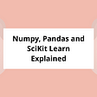

NR

·Dec 15, 2019

Fetching an API using Redux and useEffect
This article will be dedicated to the sometimes troublesome road of fetching data over an API using Redux and Hooks in a React Native framework. I’ll be fetching data from the Foursquare API. I wanted to write this article to maybe help others having a hard time finding the “HOW”…

React Native

5 min read



NR

·Nov 6, 2019

Well.. decisions have been made
After long consideration, and a short trip to Milan, I decided to go for the second idea! This because I experienced myself that it’s really annoying when you don’t have an idea of where to eat or drink in a new city. While still at home, I browsed quite a few sites to find trendy restaurants and inside must-go-to places. Once arrived in Milan, I realized that I forgot to save or pin those places. So I guess that was my moment of making this decision!

Travel

1 min read



NR

·Dec 12, 2019

Using React Native Hooks — notes
React Native Hooks. One of the latest additions to the React (Native) framework. Hooks were officially released in React 16.8 and React Native since the 0.59 version. What are Hooks? Hooks are the solution to let you use state and other React features in a function component. Before the 16.8 …

React

6 min read



